IBM COGNOS ANALYTICS DASHBOARD
ON
COFFEE REVIEWS
MINOR PROJECT REPORT

Submitted By:

Saipranathi Samala,(18UK1AO549)

ABSTRACT

Flavor continues to be a driving force for coffee’s continued growth in the beverage market today. Studies have identified the sensory aspects and
volatile and non-volatile compounds that characterize the flavor of different
coffees. This review discusses aspects that influence coffee drinking and aspects such as environment, processing, and preparation that influence flavor. This summary of research studies employed sensory analysis (either descriptive and discrimination testing and or consumer testing) and chemical analysis to determine the impact aspects on coffee flavor.The coffee market is currently worth USD 15.1 billion and growing. This market is mainly comprised of roasted, instant, and ready-to-drink (RTD) coffee . The flavor of a roasted coffee brew is influenced by factors such as the geographical location of origin, variety, climatic factors, processing methods, roasting process, and preparation methods. The differences in sensory properties can, in turn, affect consumers’ preferences for and emotions or attitudes toward coffee drinking .

INTRODUCTION

Overview:
Coffee is an integral and pervasive aspect of hospitality and is part of many, if not most, travel and tourism experiences. Coffee consuming, exhibited through coffee shops, is a resource for the development of coffee-related tourism. In regards to attracting more customers and to offer a strong value proposition, coffee shops must be accessible for all, barrier- free and implement the concept of accessible tourism.There were three characterisics that were more important to customers than the rest
- Unique flavour
- Body or mouth feel
- Finish or aftertaste

Coffee shop, considered the third most important place after home . coffee makes our customer feel happy and warm like perfect rays of sunshine.With the best sorted coffee beans from across the country, it strive to provide the most refreshing coffee. To offer exquisite tastes, from classic-retro flavors to the most trending ones to all coffee lovers under one roof is our aim.With a broad customer base, aspire to become the favorite coffee brand of the people. Many costumers like the experience of trying something new and therefore enjoy coffees with unique flavours

- Purpose:

The purpose of this coffee review is that to get feedback from the customers on what quality of coffee and flavour meant to them . The overall project purpose is that we will be analysing some important visualizations ,creating a dashboard on the basis of coffee shop and flavour reviews and by going through these we will get most of the insight of coffee reviews in India.

LITERATURE SURVEY

2.1Existing problems:

Determining the best material and quality for coffee review analysis is a difficult task for a human as we has to consider different number of parameters and come up with a conclusion. Once the visualization is difficult to analyze the data and find who is consumed more coffee and the feedback the coffee shop gets and also the flavours of the type of coffees they like etc……
It is quite difficult for a human to work with such a huge and typical data. So here we are coming up with a solution.

2.1Proposed solution:

Services used: IBM cognos analytics

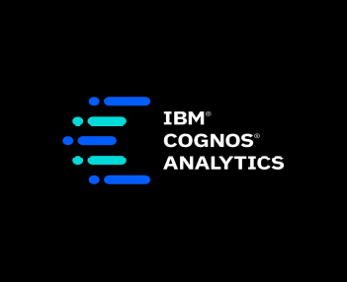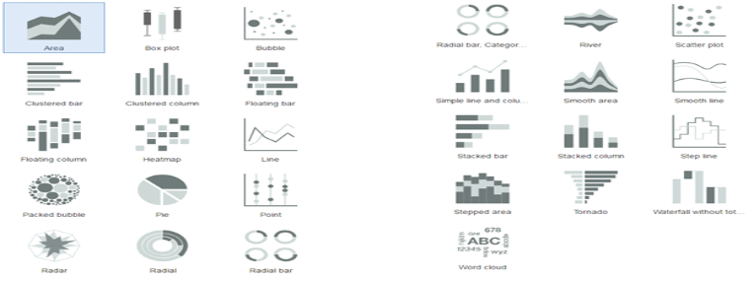

IBM cognos analytics dashboard can end up with the best solution for every visualisation problem.Some here we are going to use the rich set of IBM analytics dashboard to visualization the data in easy way.

By using the visualization in dashboard we can analyze the any analysis from any data.

IBM CONGNOS ANALYTICD DASHBOARD ON COFFEE REVIEW
Before creating the dashboard there is a process where the files and data sets are extracted and uploaded into the watson discovery where we create a new data collection
Process for data extraction:
The process will be
- Launch the watson discovery
- Create a new datacollection
- Add keyword enrichment in the enrich feild tab present in the watson discovery where remaining enrichments aready has been leisted by default
- Select all 998 json review files located in the data/coffee_reviews directory and upload it into collection

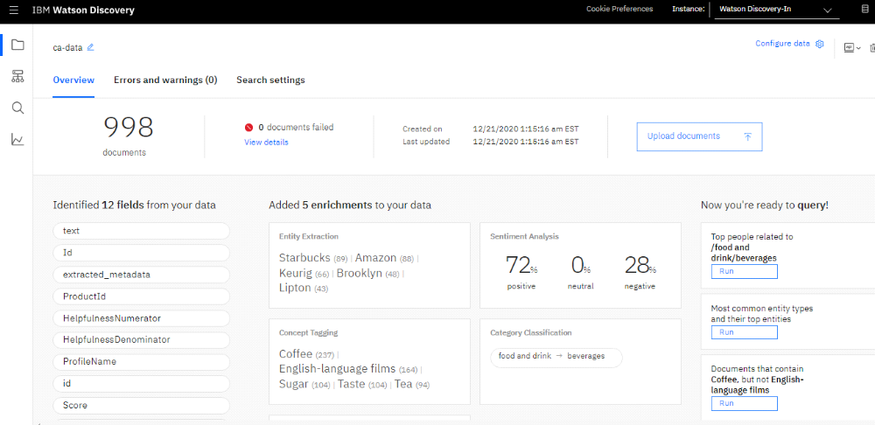

Adding service credentials to the environment files:
- From the home directory of cloned local repo, create a .env file by copying it from the sample version.
cp env.sample .env

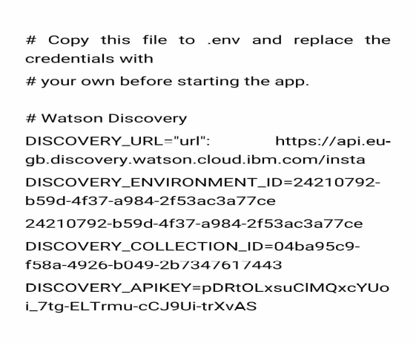
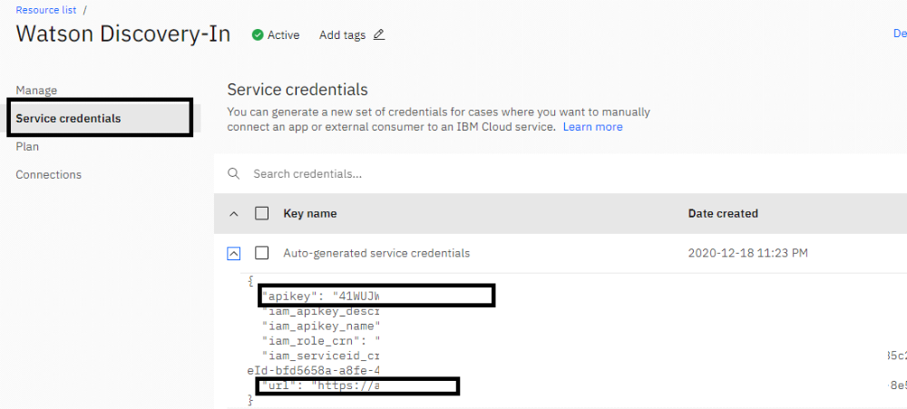
- By using the above methods we created the dashboard using the datasets which is uploaded and extracted from the watson discovery
(where datasets was already provided by the smartbridge )

THEORTICAL ANALYSIS

3.1Block diagram:
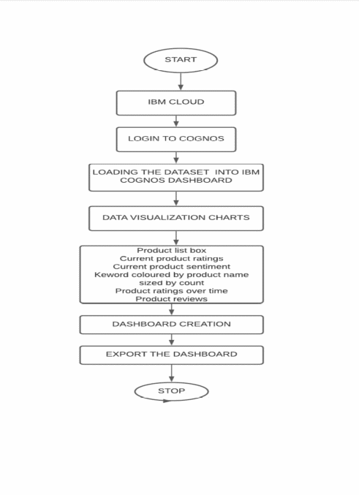

HARDWARE/SOFTWARE DESIGNING:

Software specifications:

REQUIREMENT | SPECIFICATION
IBM ACCOUNT | You must have an account in Ibmprior to begin.
Ibm cognos analytics dashboard | - Contains Different Visualization  - One should Launch the cognos analytics dashboard
Web browser | For all Web browsers, the following must be enabled:  - cookies  - JavaScript

Hardware specifications:

REQUIREMENT | SPECIFICATIONS
Operating system | Microsoft Windows  UNIX  Linux®
Processing | Minimum: 4 CPU cores for one user. For each deployment, a sizing exercise is highly recommended.
RAM | Minimum 8 GB.
Operating system specifications | File descriptor limit set to 8192 on UNIX and Linux
Disk space | A minimum of 7 GB of free space is required to install the software.

EXPERIMENTAL INVESTIGATIONS:

Analysis or the investigation made while working on the solution:
While working on the solution we investigated on what is coffee reviews analysis, IBM cloud, IBM Watson studio, Ibm cognos service, Cloud Object Storage. The key role on investigation is collection of dataset.

IBM CLOUD ACCOUNT:

IBM Acquired soft layer, a public cloud platform, to serve as the foundation for its IaaS offering. In October 2016, IBM rolled the soft layer brand under its Blue mix brand of PaaS offerings, giving users to access both IaaS and PaaS resources from a single console. IBM cloud provides a full-stack, public cloud platform with various products in the catalog, including options for compute, storage, networking, end to end developer solutions for app development, testing and deployment, security databases, and cloud native services.
Creating the IBM cloud account by going to the IBM cloud login page and click create on IBM cloud account. Enter our IBM id and an ID is created based on the email that we enter. Completing the remaining fields with our information and click create account by this the account is created.
DATASET COLLECTION:

The data collection on coffee reviewsanalysis by:

- Articulate the problem early.
- Establish data collection.
- Check our data quickly.
- Reduce data.
- Take the required fields of data

FLOW CHART:

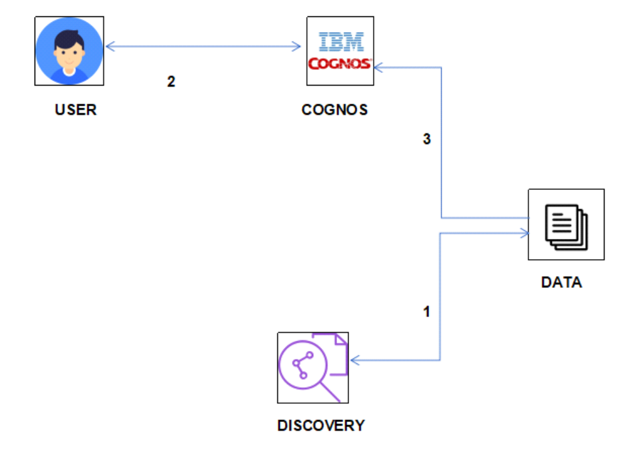

RESULTS:
Final output of the project:
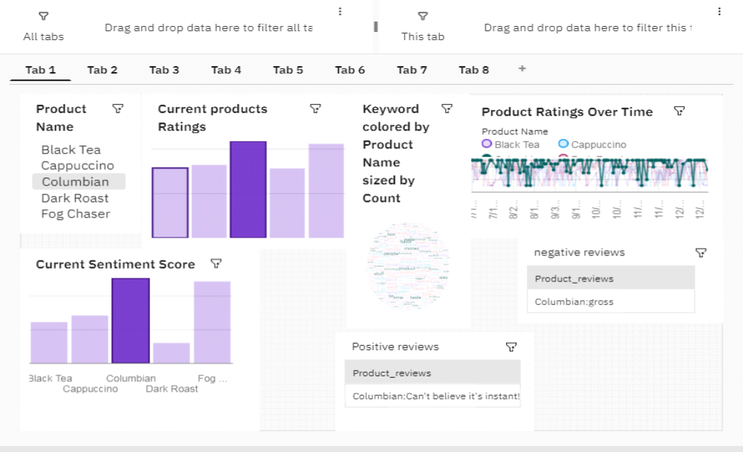
1000-REVIEWS DASHBOARD
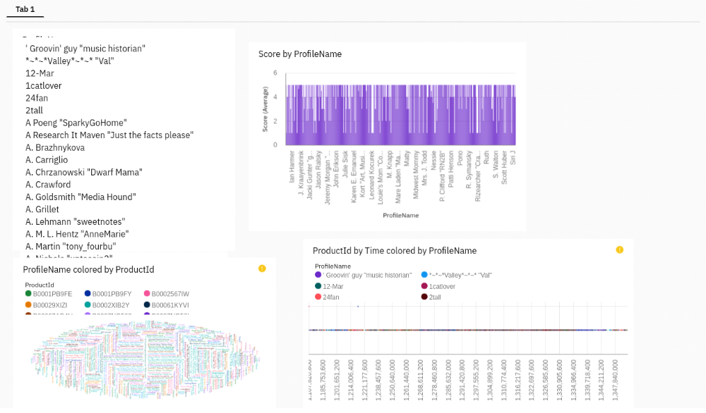
ADVANTAGES AND DISADVANTAGES:
ADVANTAGES:

- Lower costs—reduces maintenance due to complete report coverage and a zero-footprint environment.
- Faster results—shortens reporting time due to seamless integration and adaptive authoring.
- Improved decision making—reports and dashboards present data in easily-understood formats.
- Ability to work with data using familiar business terms.

DISADVANTAGES:

- Total cost of ownership(TCO)is more significant than other tools
- Investments in cognos R&D by IBM is declining
- Wont work smoothly with large data sets having many parameters
- Cross-browser compatibility is often problematic

APPLICATIONS:
The areas where this solution can be applied:
- Coffee reviews analysis using Ibm Cognos Dashboard
- The Visualization can be done by using visualization tools

CONCLUSION:
- From this entire findings we know fundamental concepts and can work on IBM COGNOS
- Gain a board understanding of visualization
- Learn to build stunning models on IBM Cloud
- To create data visualizations to understand
FUTURE SCOPE:
- Enhancements that can be made in the future:
- This model can be further developed to suggest any analysis can be done by using Ibm
- Cognos Dashboard and coffee reviews analysys were done by this visualizations based on the input parameters
- We can scope the better job in future with easy experience
BIBILOGRAPHY:
References of previous works or websites visited/books referred for analysis about the project,previous solution findings

